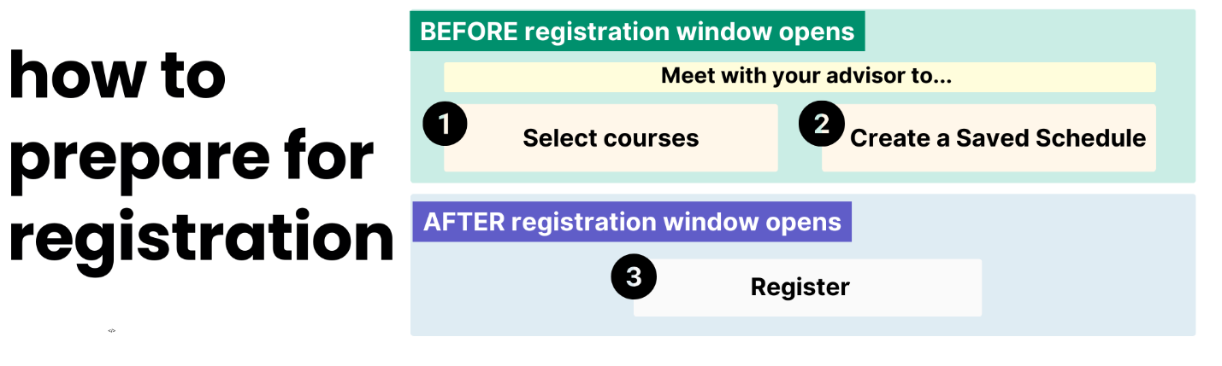
Use this reference to research available course sections in preparation for registration.
Before you meet with your advisor to select courses and create a saved schedule in Workday, research available courses. There are two ways to research course sections:
Option 1: WCU Course Look-up Tool
Option 2: Workday

Option 1: WCU Course Look-up Tool
The Course Look-up Tool is an easy-to-access method for researching course options. When you are ready to create a saved schedule, check your eligibility, and/or register, go to Workday.
- To use the course look-up tool, go to western.edu/course-search
- In the top toolbar select undergraduate or graduate course search.

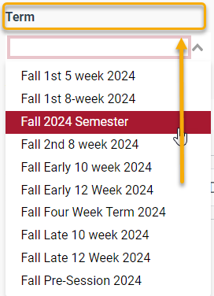
- Locate the Term field and select one option.

- Use the other filters. The search bar is not recommended.

NOTE: Only one item in each filter can be selected at a time.
TIP: Start your search wide and then slowly narrow your results with additional filters.

- Click “Search”.


If you want this… | Then, do this….
If you want to search only lower division or upper division courses… | Then, set the Search by Tags filter to “Lower Division” or “Upper Division”.
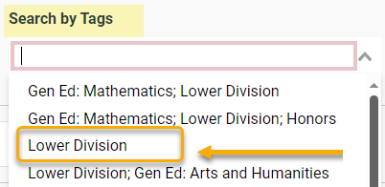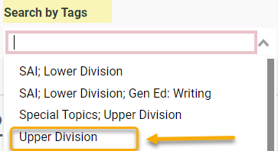

Selecting “Lower Division” will result in 000-200 courses. Selecting “Upper Division” will result in 300+ courses.
HELPFUL TIPS

If you want to see only online classes… | Then, set the “Online Only” toggle button to “On” and click “Search”.

This results in courses with Delivery Mode: Online.

If you want to know if a course is waitlisted… | Then, review the Availability field. If it’s green, the course is accepting registrations.
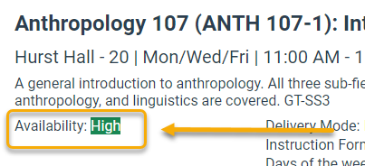

If the course is full, availability will be red.

If you want to know whether you meet prerequisites… | Then, review the course description. Prerequisites are outlined in bold.
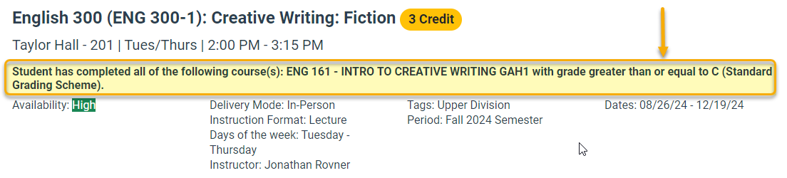

If you are still not sure if you meet the prerequisite, follow these steps:
- Log into your Workday account and click “Academics”.

- Click “Find Undergraduate/Graduate Fall Course Sections”
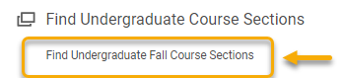

- Type the course name in the search bar. In this example, the search is for ENG 301.
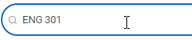

- Right-click the course name to open in a new tab.
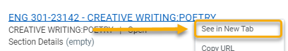

- On the View Course Section page, review details to confirm this is the correct course you are looking for. Click “Troubleshoot”. This will display any obstacles that would inhibit you from registering for this course. If you see the “Register” button only, then you are eligible to register.


- If you have additional questions or concerns, speak to your advsior.

Option 2: Workday
- Log into Workday and enter the Academics app.

Click “Find Undergraduate Course Sections” or “Find Graduate Course Sections” to view all available courses.

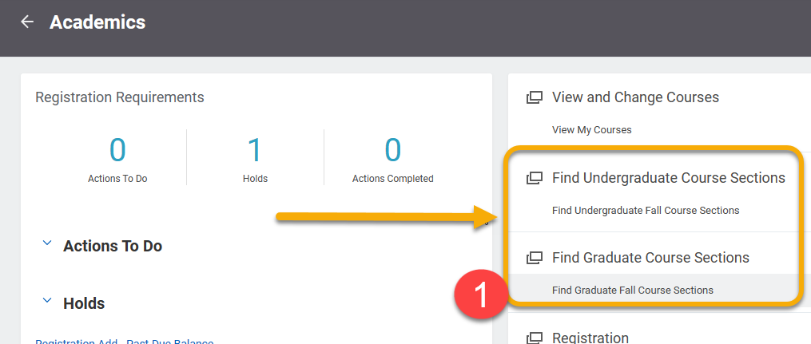
TIP: When navigating in Workday, right click on links whenever possible to open pages in a new tab. It will allow you to return to the Academic app or search results more quickly.

- The Find Undergraduate/Graduate Course Sections page features two ways to search for courses: Search Bar and Left-hand Menu.

- Search Bar: To use the search bar, type keywords, subject (e.g. CHEM or ENG) or the exact course section (ENG 102 or ENG 102-03) and press Enter or click “Search”.

- Left-Hand Menu: Use this menu to filter results by criteria. Below are some of the most commonly used search filters.
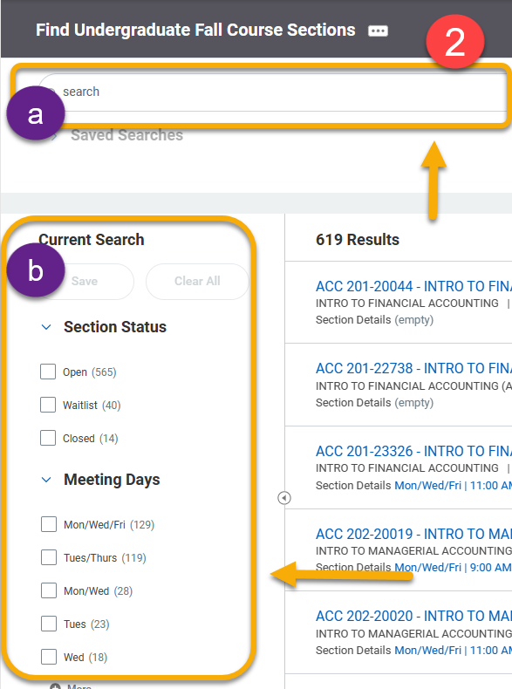
Filter | Description | Examples
Meeting Days | Narrows results by the day(s) of the week. | E.g. Mon/Wed or Tues/Thurs
Section Status | Displays courses based on capacity levels and availability | Open, Waitlist, Closed
Academic Period | Narrows courses by semester and parts of term | Fall semester, Fall Early 12 Week, Fall 1st 8 week
Delivery Mode | Narrows courses by method of delivery | Online, In-person, hybrid
Instructional Format | Narrows courses based on the format | Lab, lecture, internship

- Click the carrot symbol to the right of a course to view more course information.

- To view course details, right-click the course title and select “See in New Tab”.
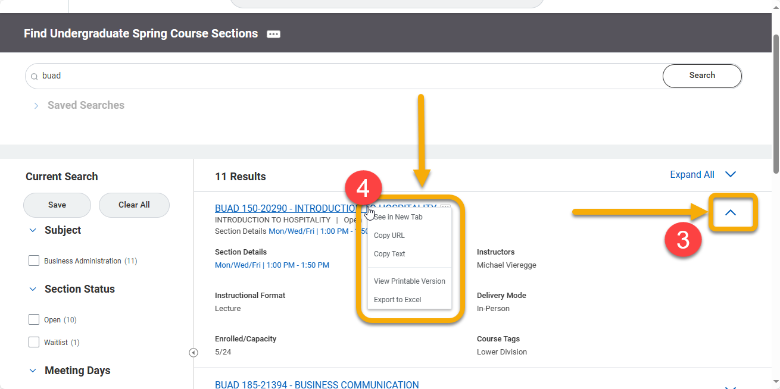
TIP: By opening the course in a new tab, you can easily close the window when finished and return to your search results.

- The View Course Section page will display all course information. Important highlights are below:

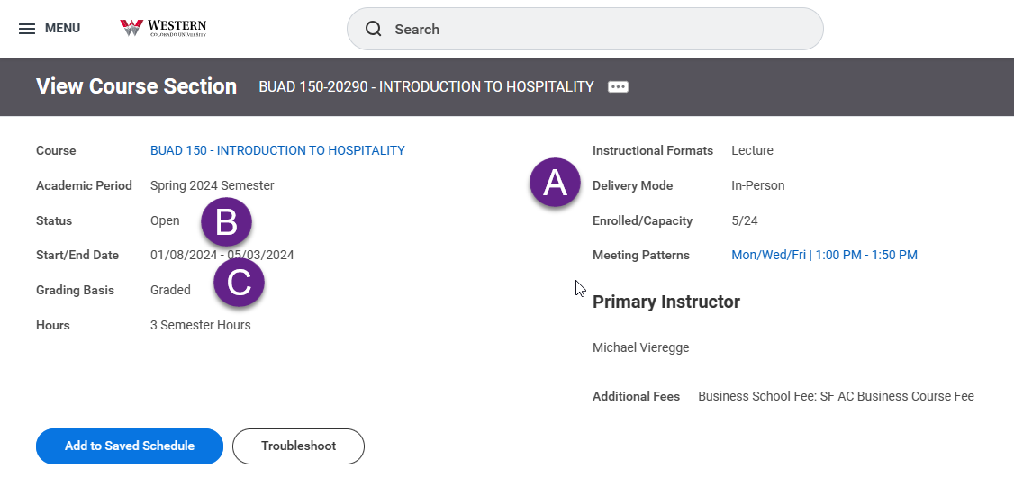
- Instructional format indicates whether the section is a lecture or lab.

- Status indicates whether the course has reached capacity. It will display either Open or Waitlist.

- Grading basis distinguishes a course as graded or pass/fail.

When the registration window is open, the blue “Register” button is visible for eligible students.

When registration is closed or if you are ineligible, the page will display the “Add to Saved Schedule” button and “Troubleshoot” button.

TIP: Right-click “Troubleshoot” to confirm you meet course prerequisites. If you don’t meet the prerequisites, submit a course section prerequisite override from the Academics app homepage.

